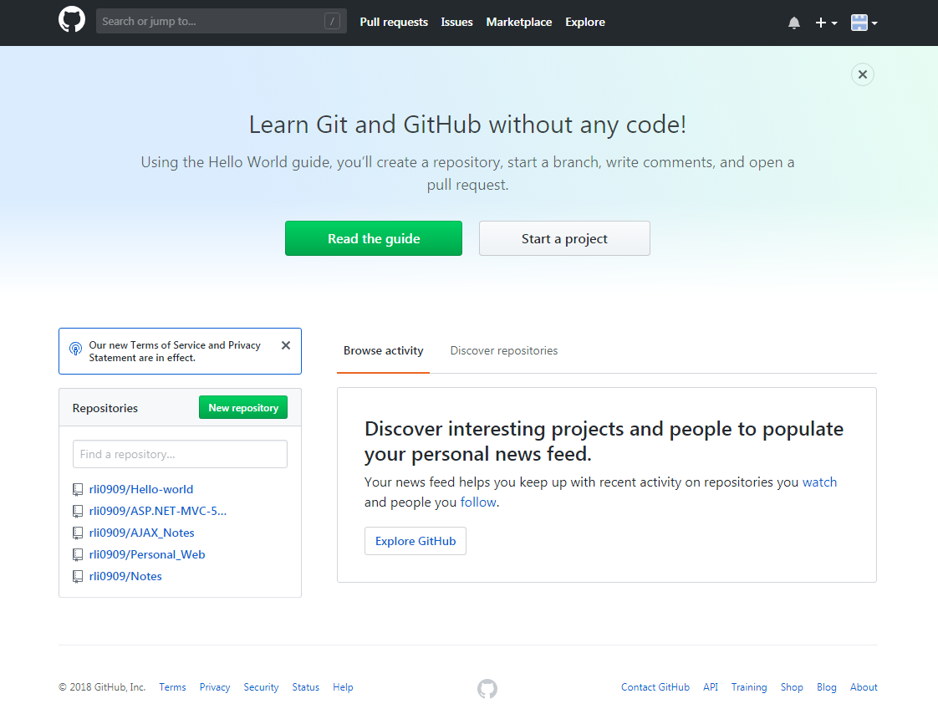

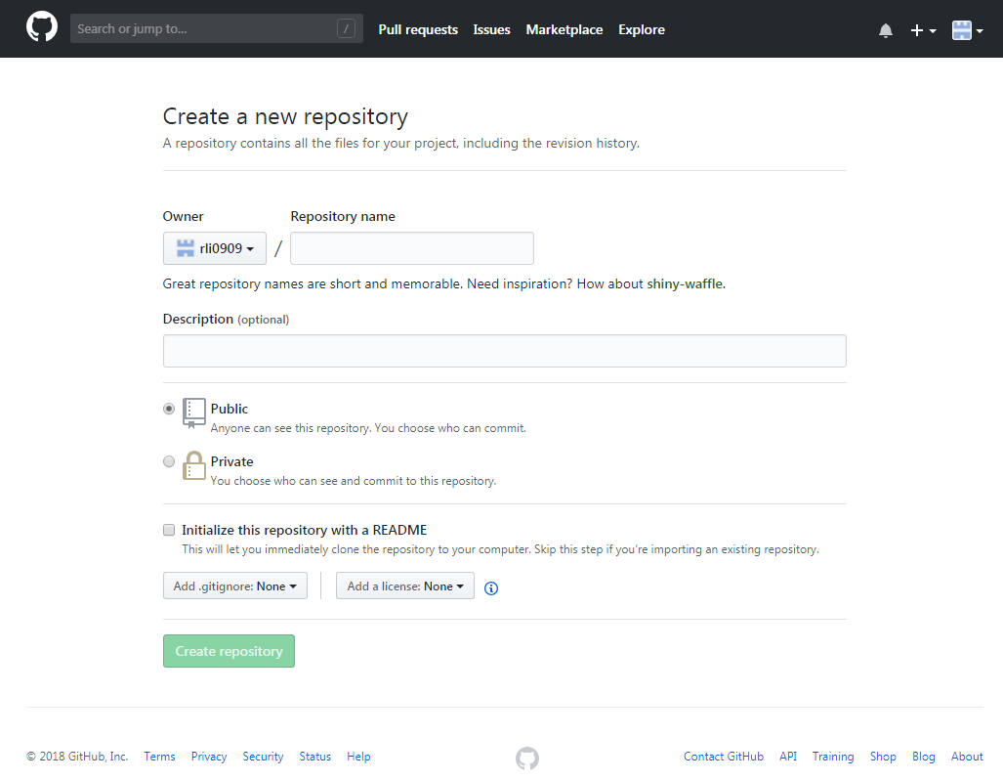

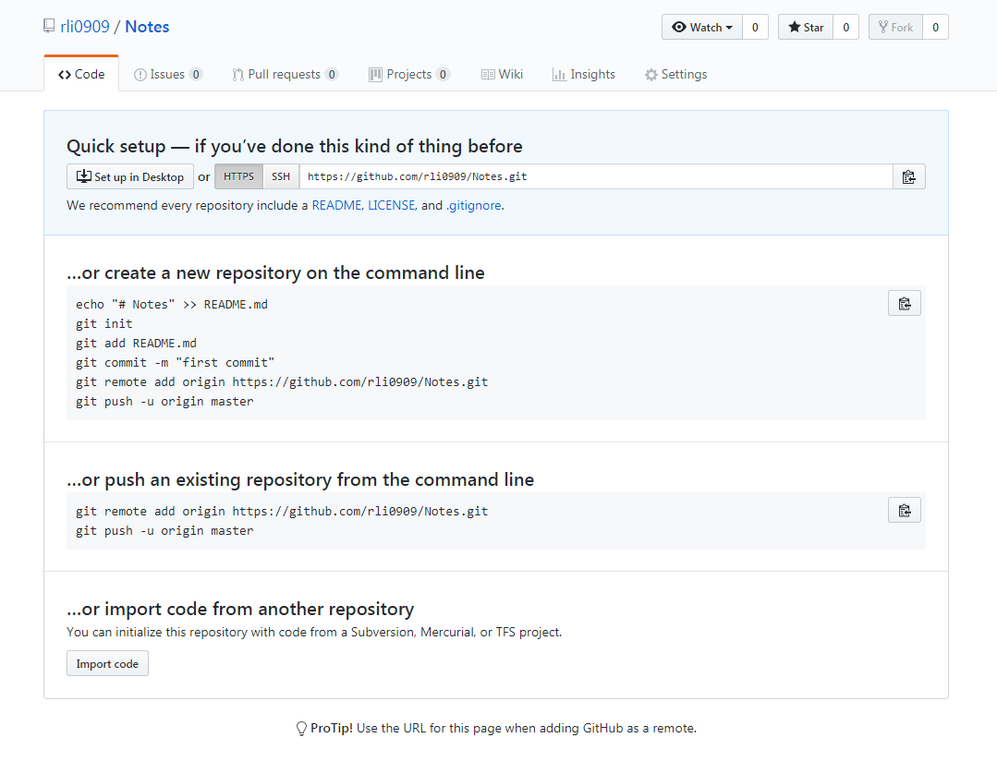

copy the URL from that page to your clipboard

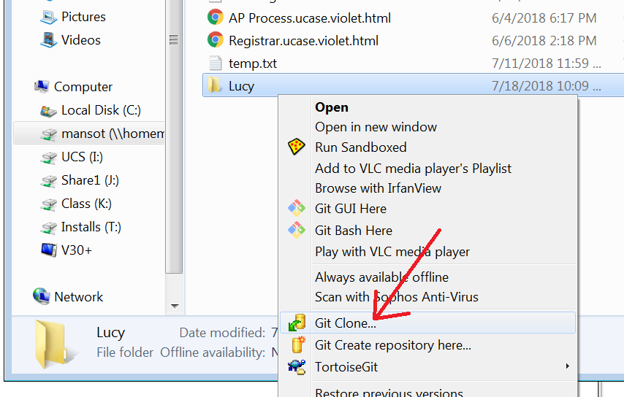

after you clone, copy your files into the new folder that was created and commit them to the repository

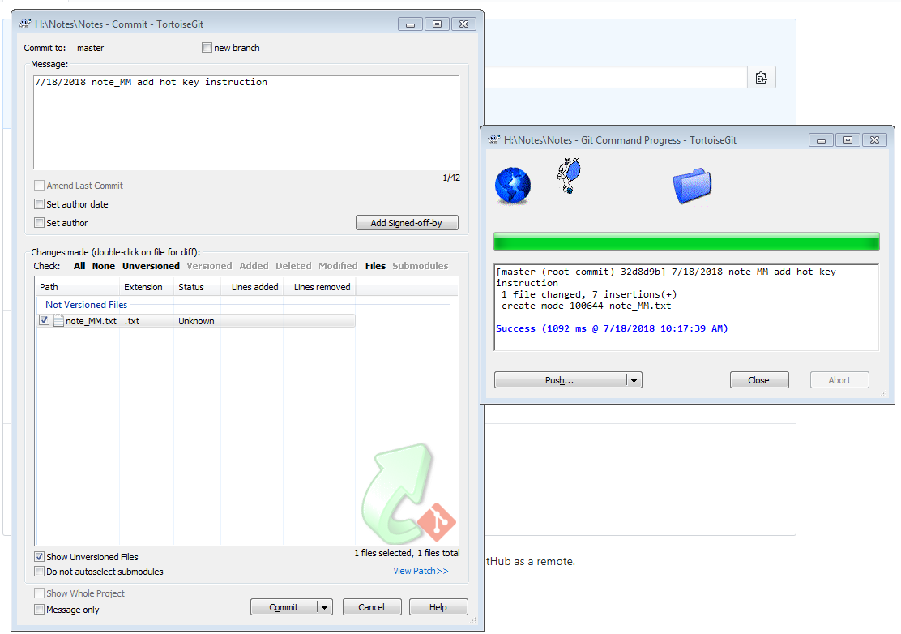

Commit will update your local repository. Push will update the one on github. You should commit as often as you need but only push when you are ready (example: you just completed a working version of your code)

for first time you should push just to get the files up there.

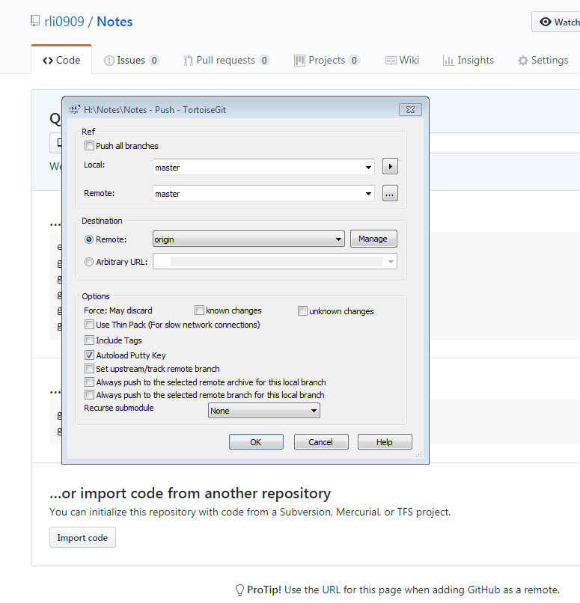

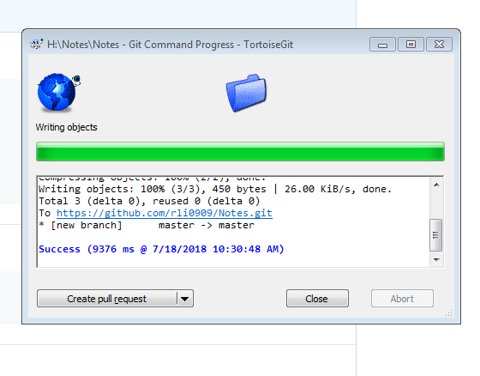

Now refresh the page, the page following :



Should changed to:

